**Get start with RAK7201**

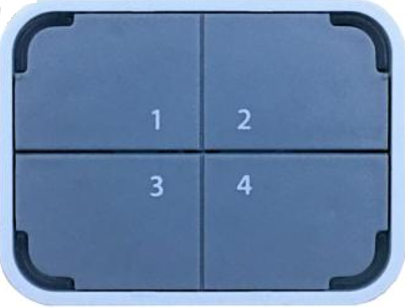

# Notice: at present, RAK7201 only supports the EU868/US915 band

# **Where is the latest firmware binary?**

If you want to get a pre-compiled firmware instead of compiling the source code by yourself, you can find the latest firmware on Github repository.

# <https://github.com/RAKWireless/Get-start-with-RAK7201/blob/master/868-22dbButton_051.bin>

<https://github.com/RAKWireless/Get-start-with-RAK7201/blob/master/915-22dbButton_051.bin>

# **How to flash the bootloader into RAK7201?**

You can flash the bootloader for RAK7201 using J-Flash of J-Link as follow:

Open J-Flash and choose the correct MCU and SWD as the following pictures show:

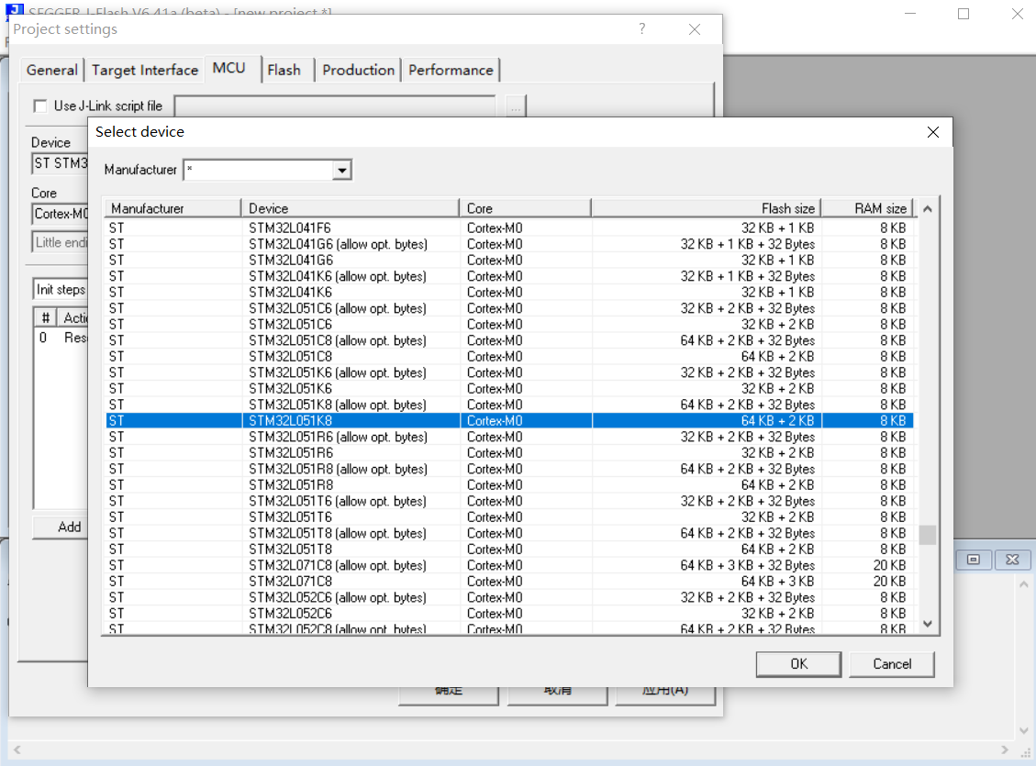

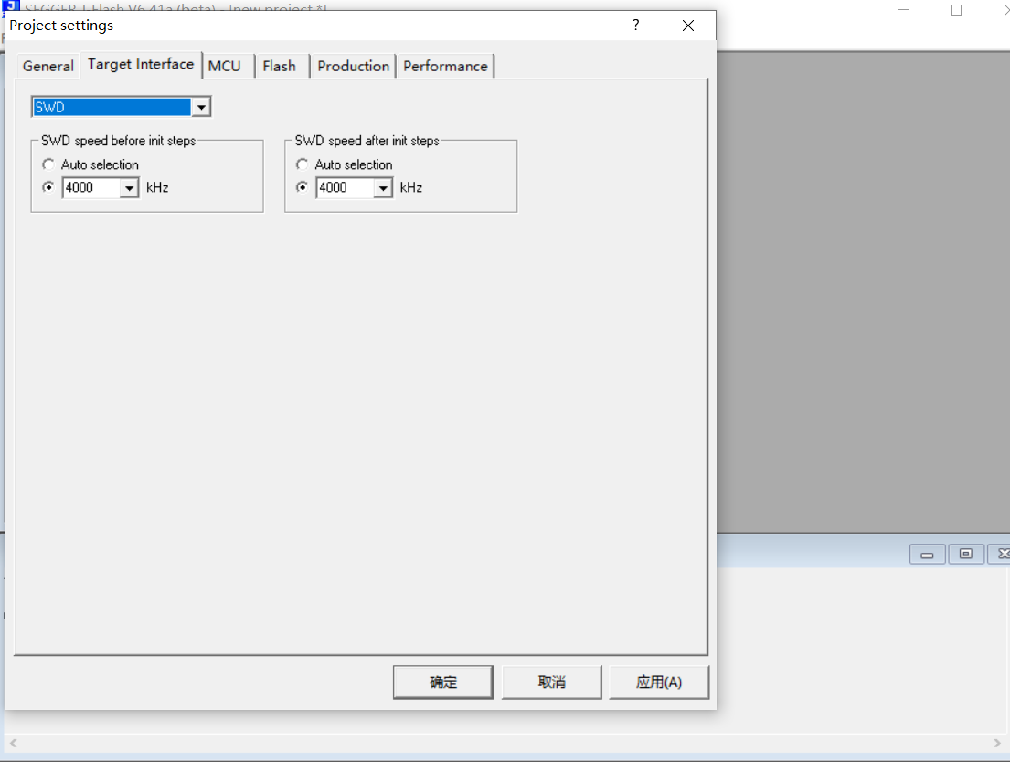

After “Connect” successfully, drag the bootloader file to the space of the following page:

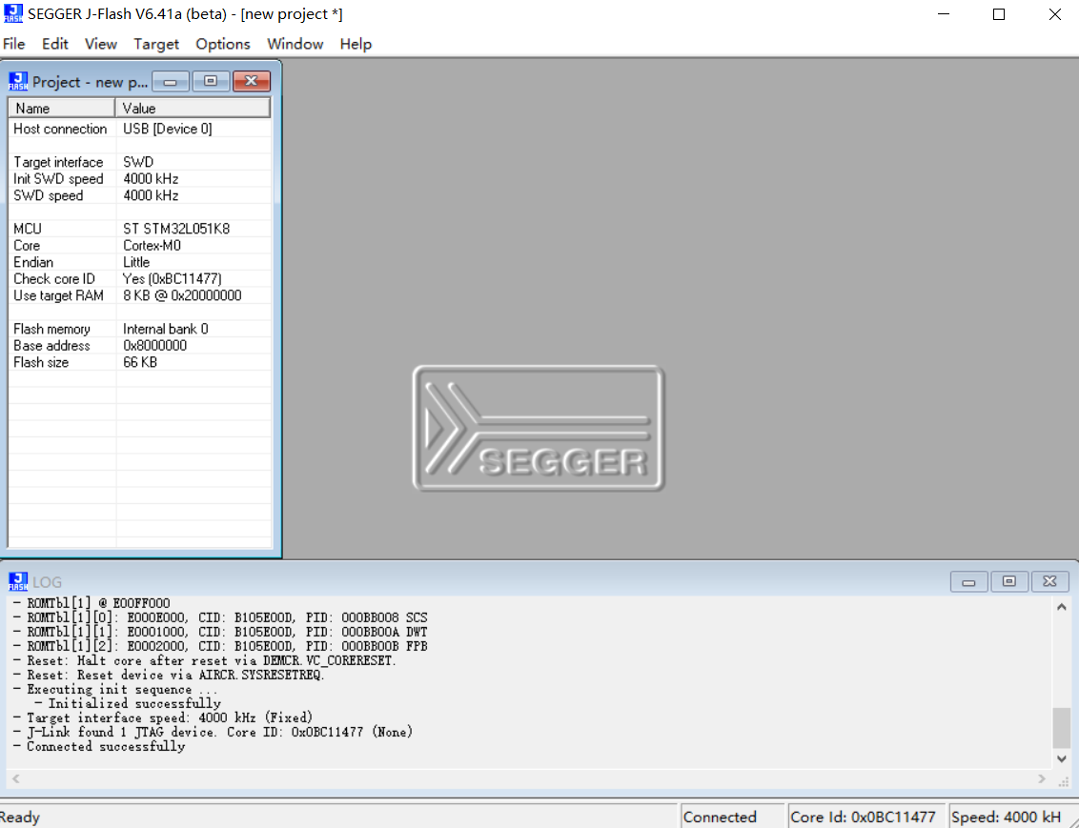

Now, “Erase Chip” firstly:

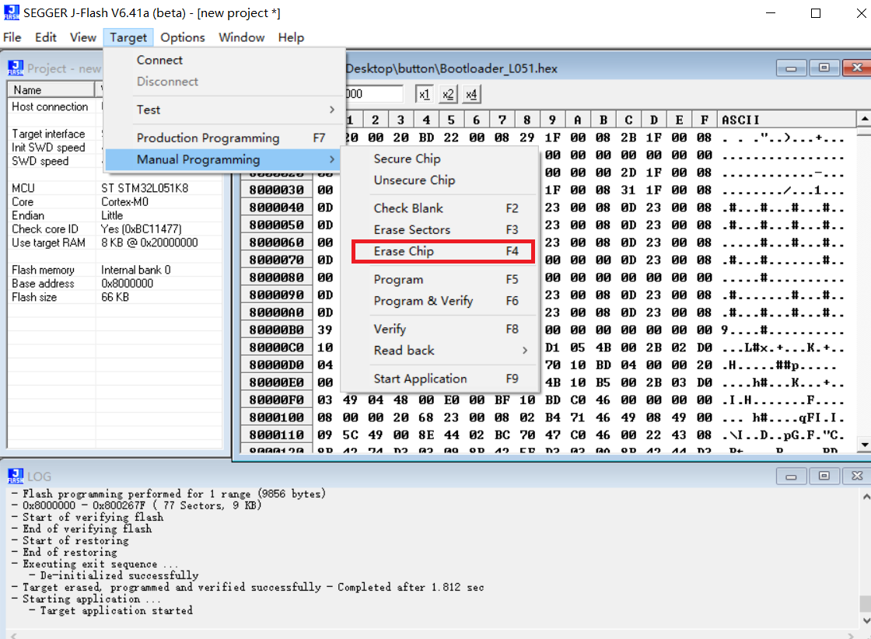

Secondly, “Program”:

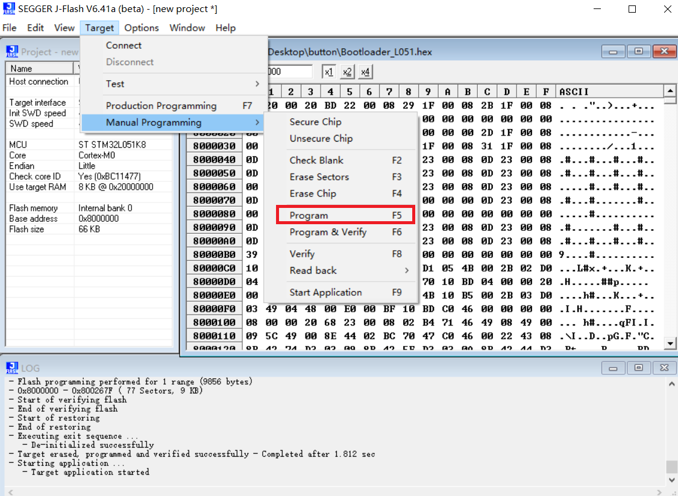

Then “Start Application”:

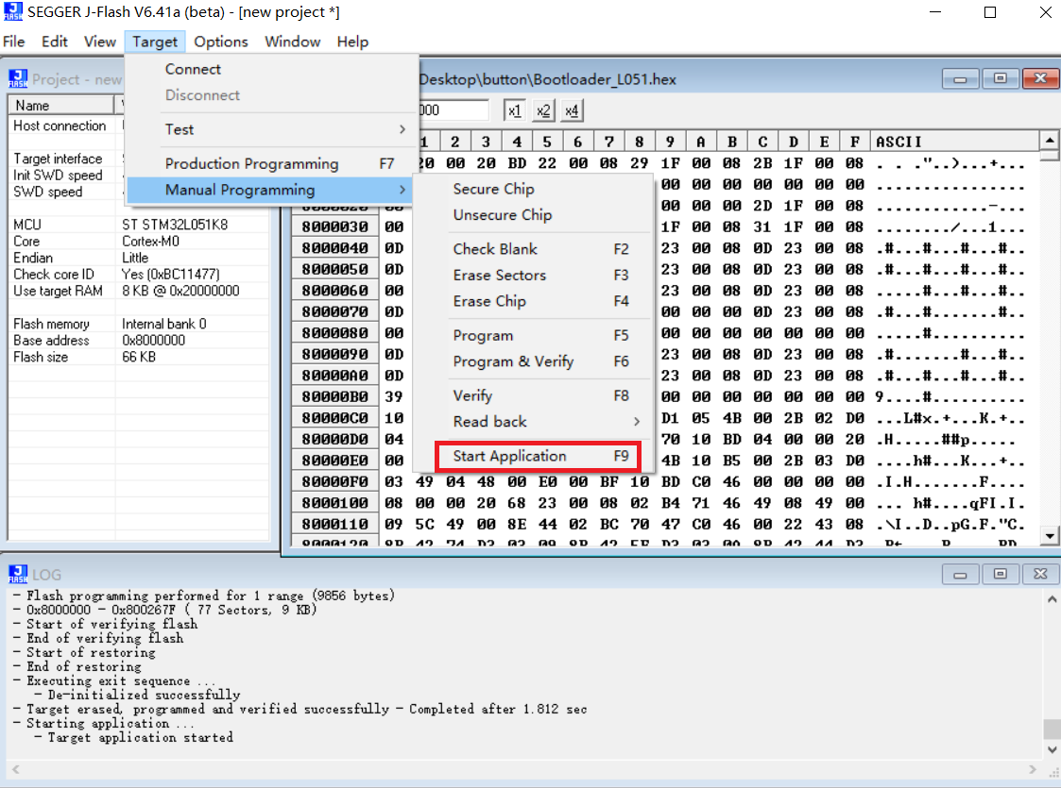

OK! We’ve flashed the bootloader for RAK7201 successfully!

# **How to burn the update firmware into RAK7201?**

If you have just burned the bootloader into RAK7201 according to the Burning Bootloader into the Device section, proceed to Step 2.

# 1.In case you have not just burned the bootloader, as instructed in the previous section you need to manually go into boot mode.

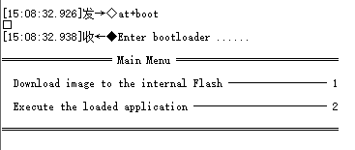

1. Open the tool “Hyper Terminal” and configure as follow:

Tool：<https://github.com/RAKWireless/Get-start-with-RAK7201/blob/master/super_terminal_v1.01.zip>

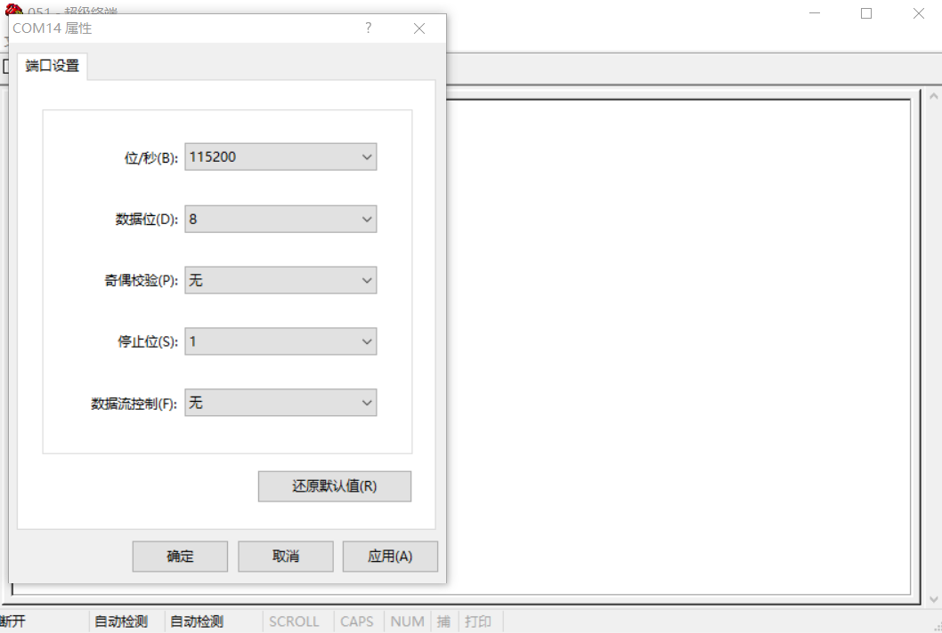

3.If it connects successfully, you can see the following information in the Hyper Terminal page:

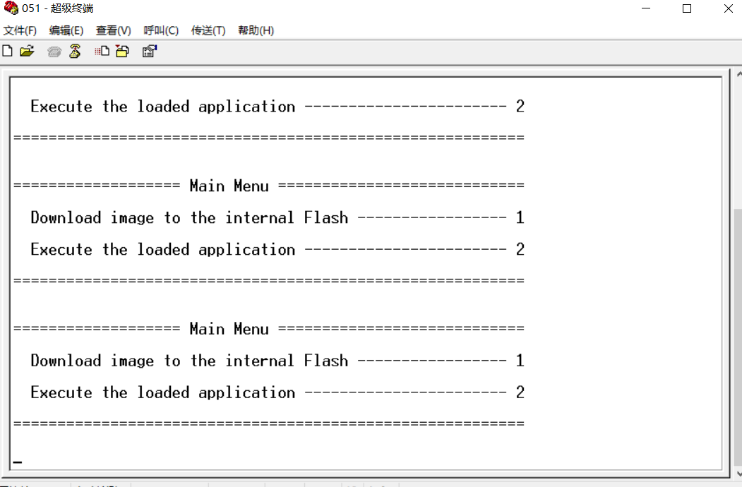

4.As you see, “1” means upgrading a firmware for RAK7201, and “2” means executing the firmware.

5.Now, type “1” to upgrade the firmware for RAK7201:

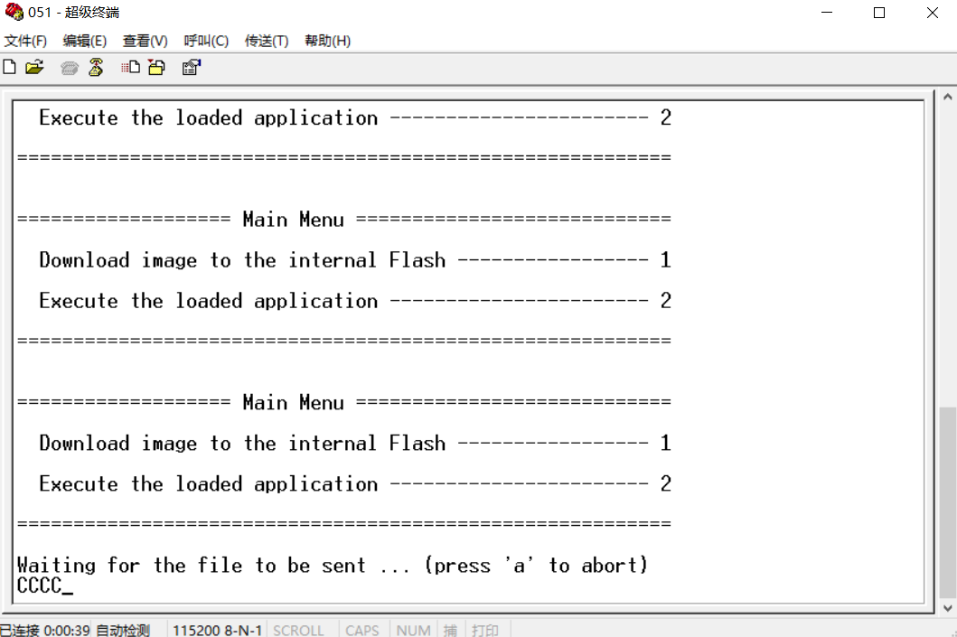

Choose the firmware file:

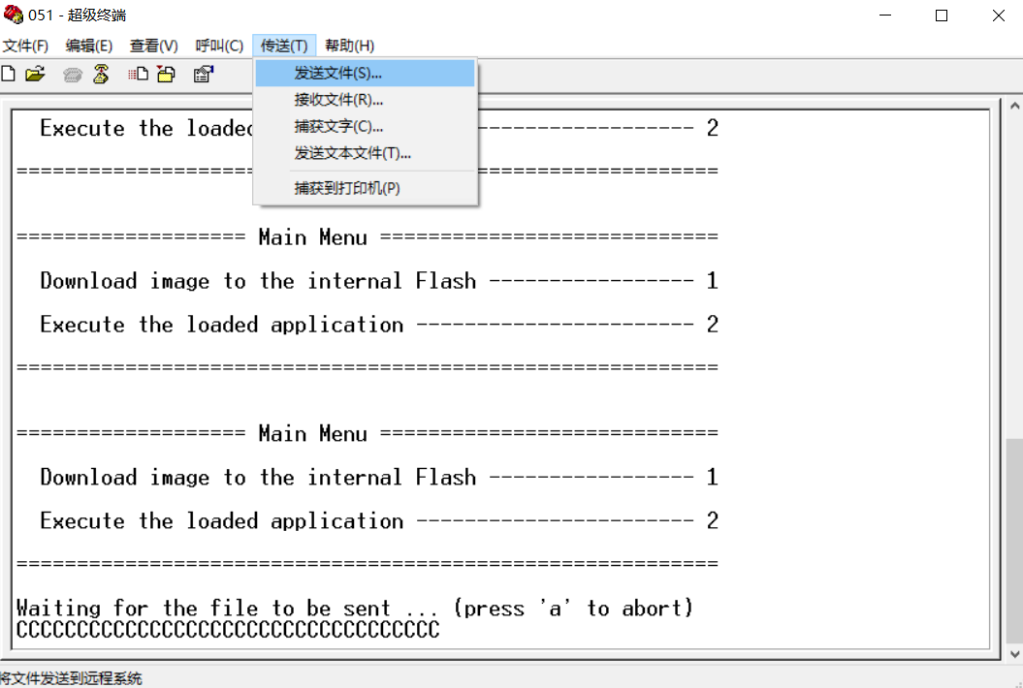

Please note that you should choose “Ymodem” as the following picture shows:

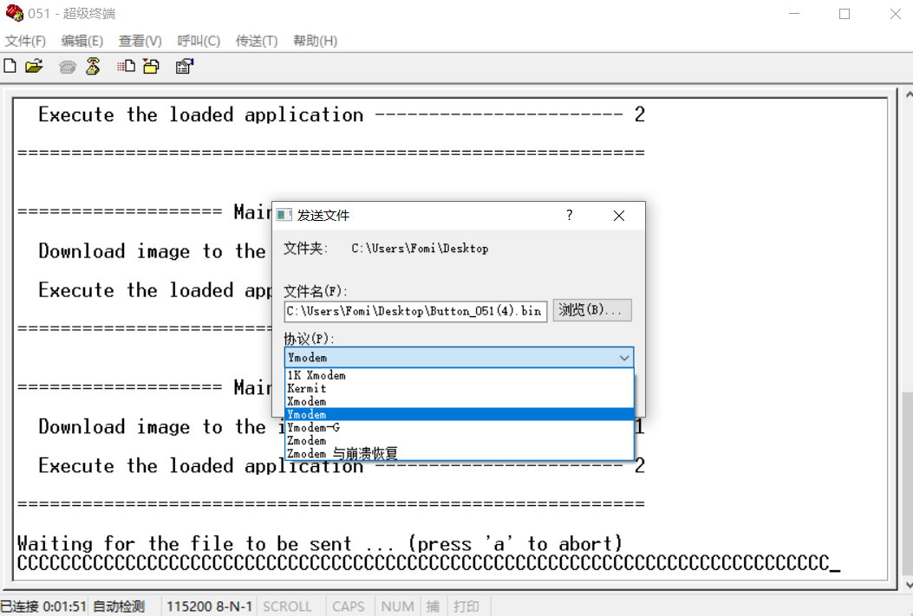

OK! Let’s start to upgrade:

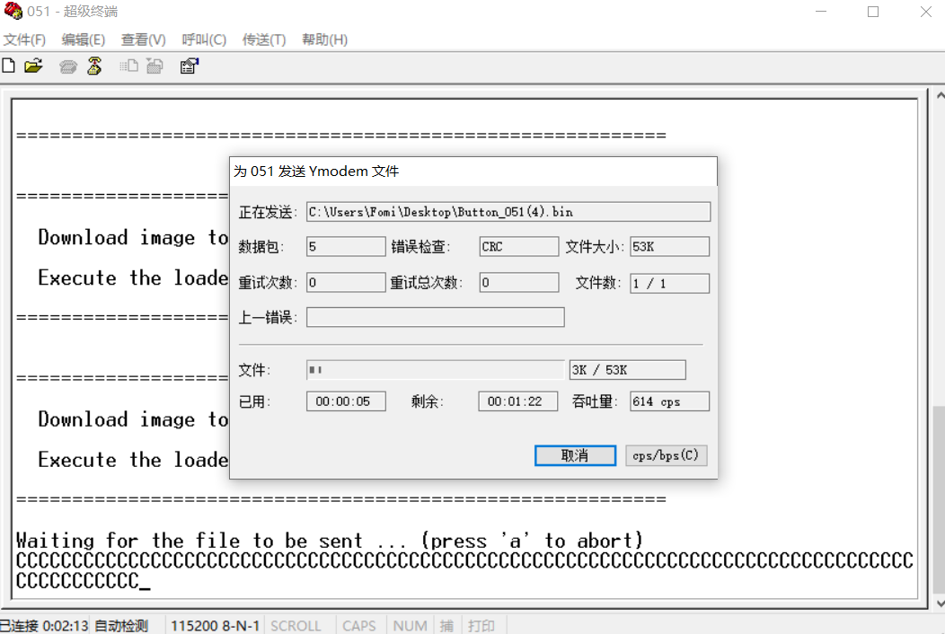

If we upgrade the firmware for RAK7201 successfully, you can see the following information:

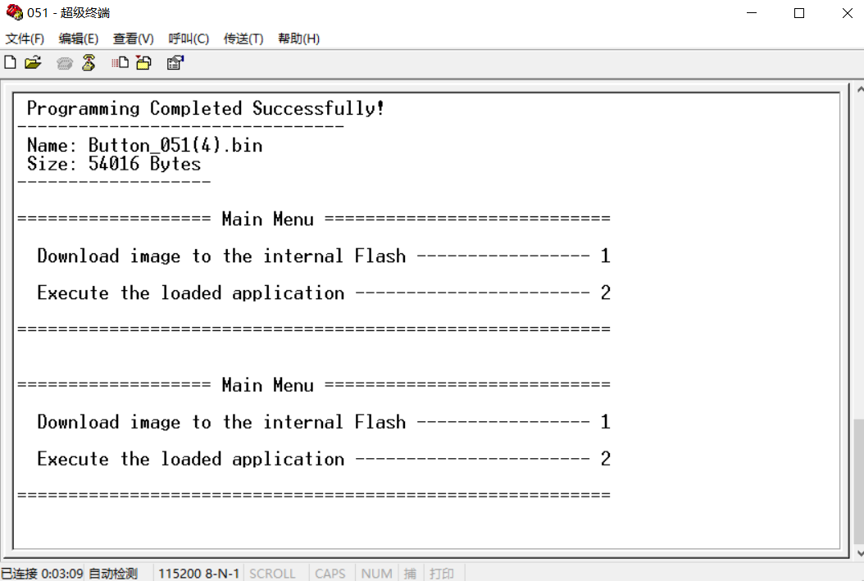

Now, type “2” to execute the firmware we just upgraded:

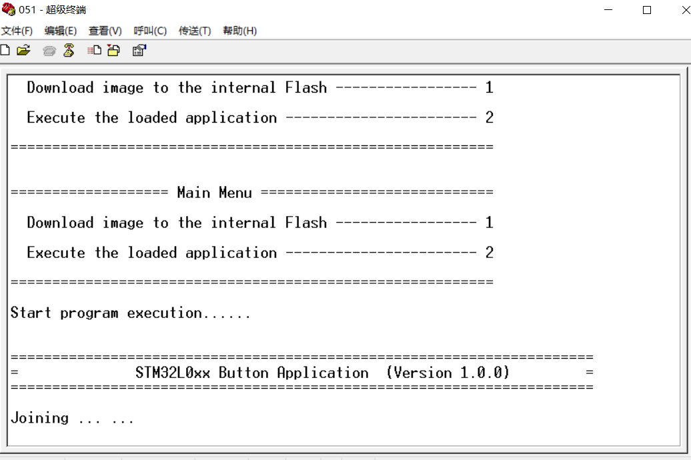

Great! As you see, it works.

Now, disconnect with Hyper Terminal, then connect with a serial port tool.

# **How to configure RAK7201?**

You can configure RAK7201 by sending AT commands into it from a serial port tool running on your PC.

Please notice that the UART of RAK7201 is disable by default because of power consumption.

If you want to configure RAK7201 through UART, you can do as follow:

Press the key 1 for several seconds until you see the led of the key 4 lights up which means RAK7201 is working in configuration mode now, and you can configure it through UART.

After RAK7201 joins successfully, you can press any key to send message as the following picture shows:

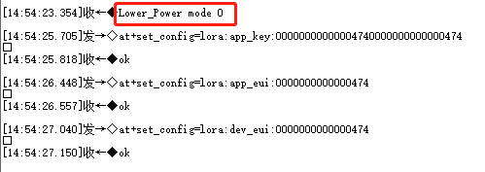

The following list shows the AT commands:

|  |  |
| --- | --- |
| **AT Command** | **Description** |
| at+boot | Let the device work in boot mode immediately. |
| at+reset | After set, the device will restart. |
| at+join | Start to join LoRa network. |
| at+get_config=lora:dev_eui | Get the device EUI for OTAA. |
| at+get_config=lora:app_eui | Get the application EUI for OTAA. |
| at+get_config=lora:app_key | Get the application key for OTAA. |
| at+get_config=lora:apps_key | Get the application session key for ABP. |
| at+get_config=lora:nwks_key | Get the network session key for ABP. |
| at+get_config=lora:dev_addr | Get the device address for ABP. |
| at+set_config=lora:join_mode:X | Set the join mode for LoRaWAN.  X definition: 0: OTAA, 1: ABP |
| at+set_config=lora:dev_eui:XXXX | Set the device EUI for OTAA.  XXXX definition: the device EUI, for example, 3534353165375300 |
| at+set_config=lora:app_eui:XXXX | Set the application EUI for OTAA.  XXXX definition: the application EUI, for example, 70B3D57ED001A1E2 |
| at+set_config=lora:app_key:XXXX | Set the application key for OTAA.  XXXX definition: the application key, for example, D9988A5F02D80FAB8BA5F453C4A2CD2B |
| at+set_config=lora:apps_key:XXXX | Set the application session key for ABP. XXXX definition: the application session key, for example, 573BD4DEC56BA4A9C462DF29E54B9BCE |
| at+set_config=lora:nwks_key:XXXX | Set the network session key for ABP.  XXXX definition: the network session key, for example, C2AA51E61BA45F57045BF48249BC36F6 |
| at+set_config=lora:dev_addr:XXXX | Set the device address for ABP.  XXXX definition: the device address, for example, 2601116D |

More information, please have a look at the next section <How to Connect with TTN?>.

# **How to connect with TTN?**

In this section, we’ll do some practice to show how to connect RAK7201 with TTN.

Firstly, open a serial port tool on your PC. I recommend you to use RAK serial port too:

<http://docs.rakwireless.com/en/LoRa/RAK811/Tools/RAK_SERIAL_PORT_TOOL_V1.2.1.zip>

Open the serial port as the following picture shows:

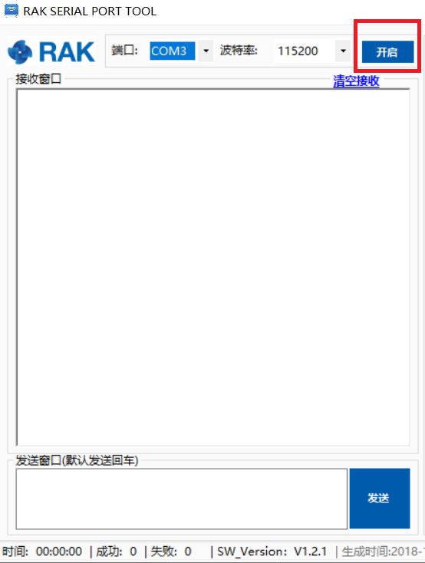

Open the link <https://www.thethingsnetwork.org/> and login, then open the “Console” page from the right corner at the top:

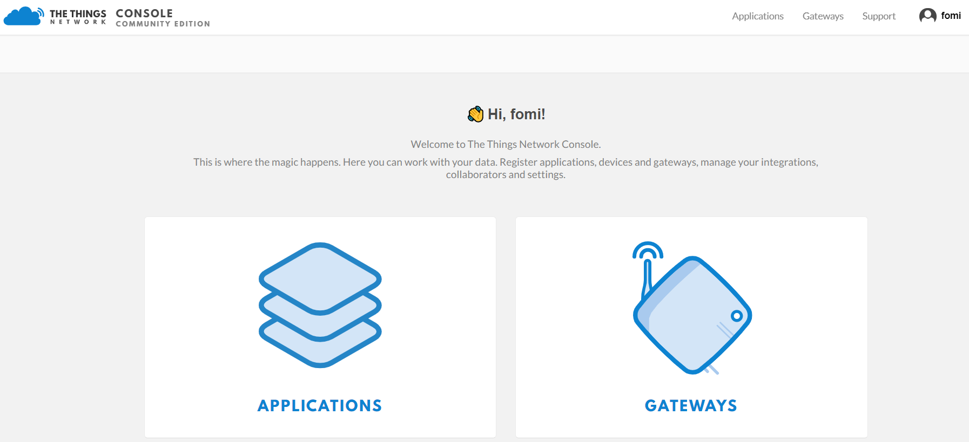

Press “APPLICATIONS”:

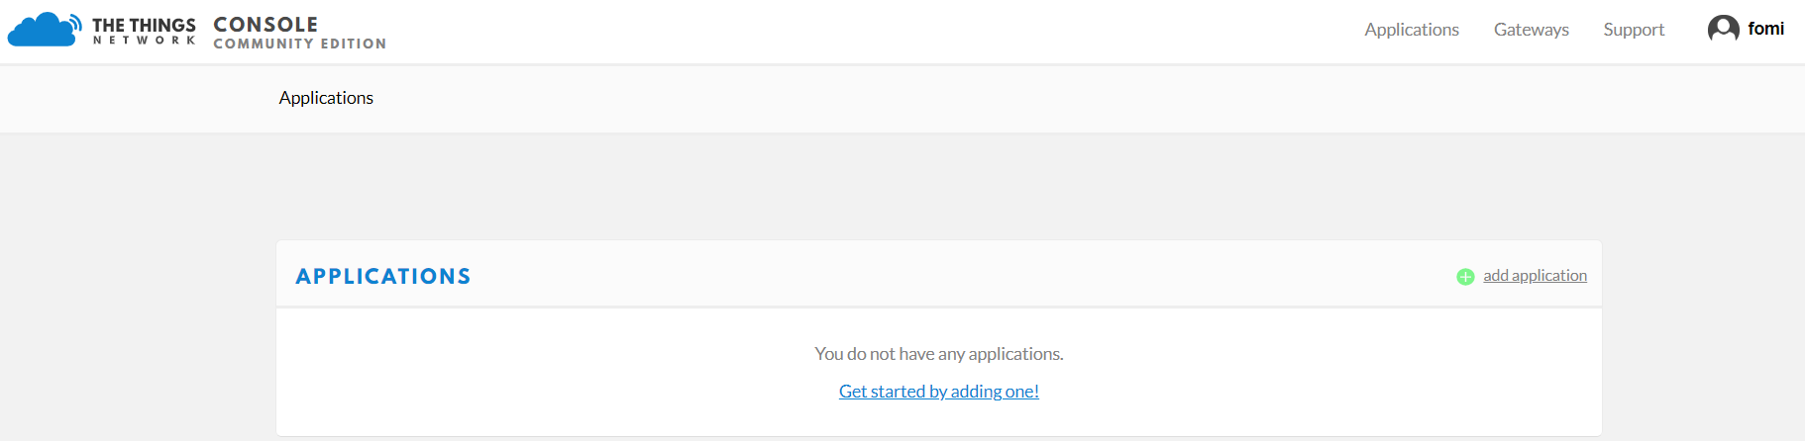

“add application”:

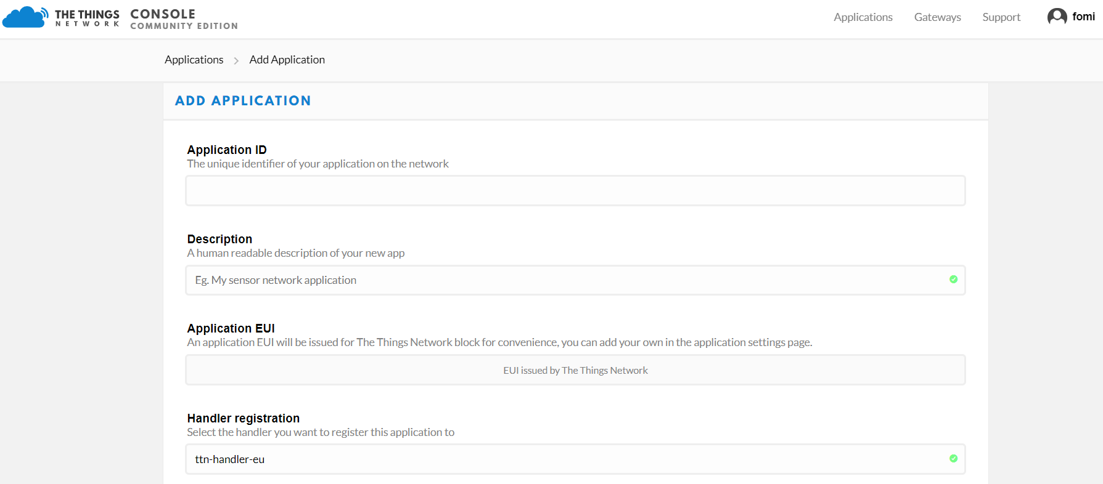

Fill in the correct contents.

Please note that the content you fill in “Application ID” item should be in low case, and it must be the unique ID on TTN network.

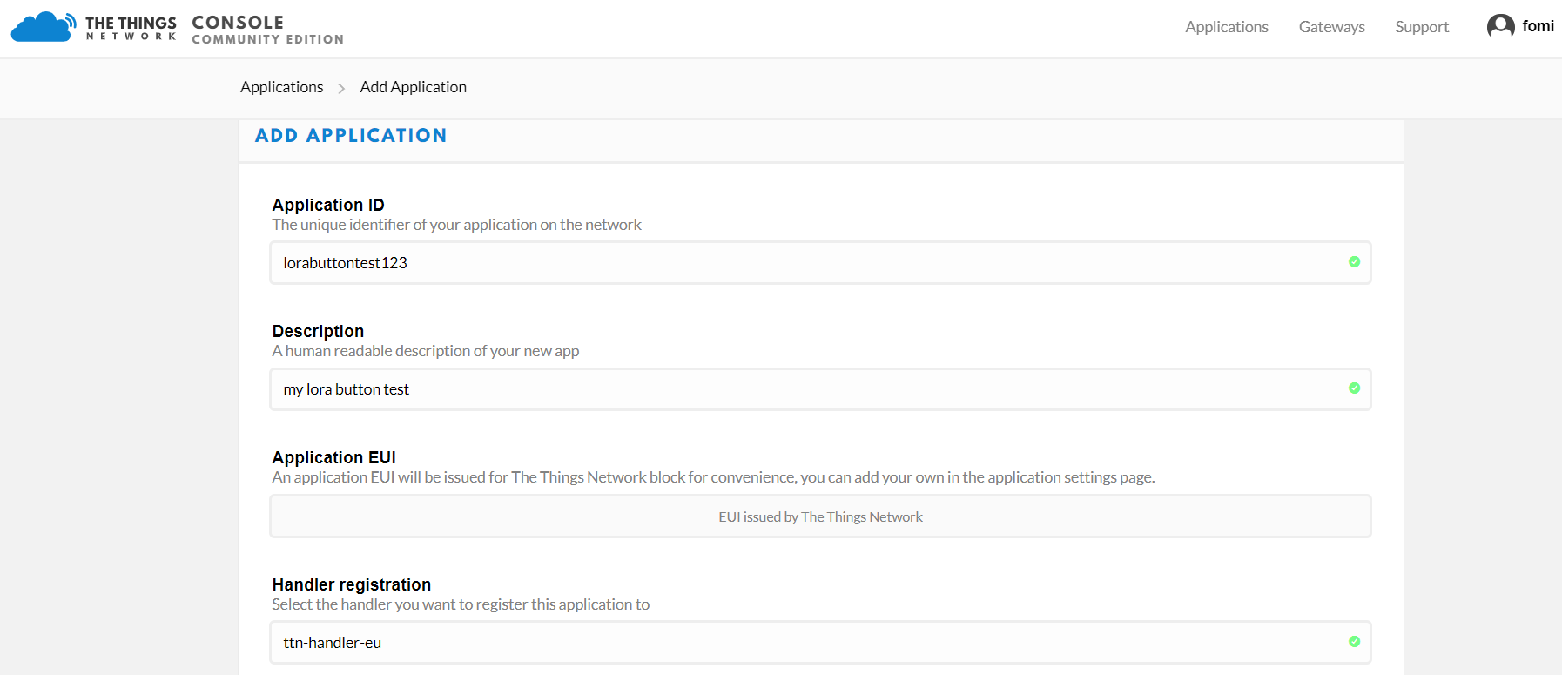

Then press the “Add application” button at the bottom of this page, and you can see the following page:

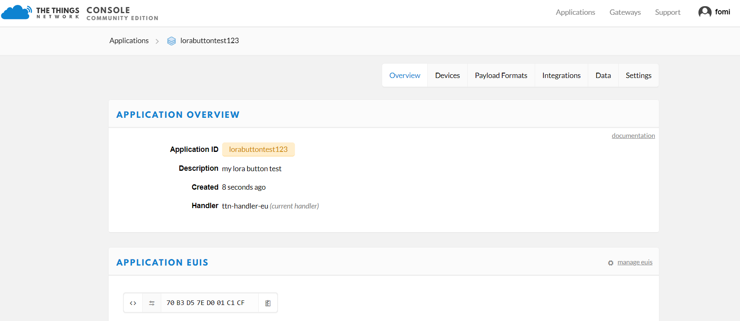

At the middle of this page, you can find the box named “DEVICES”:

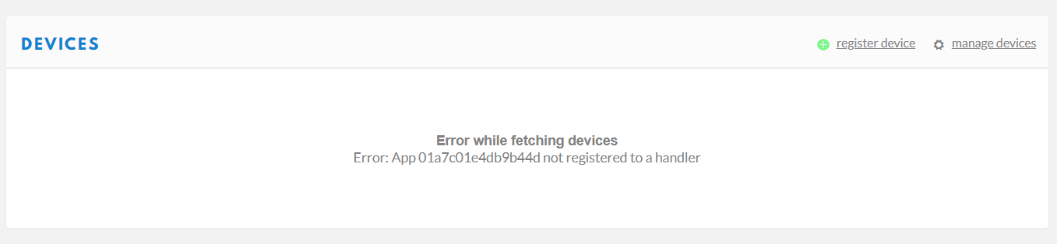

Just “register device”:

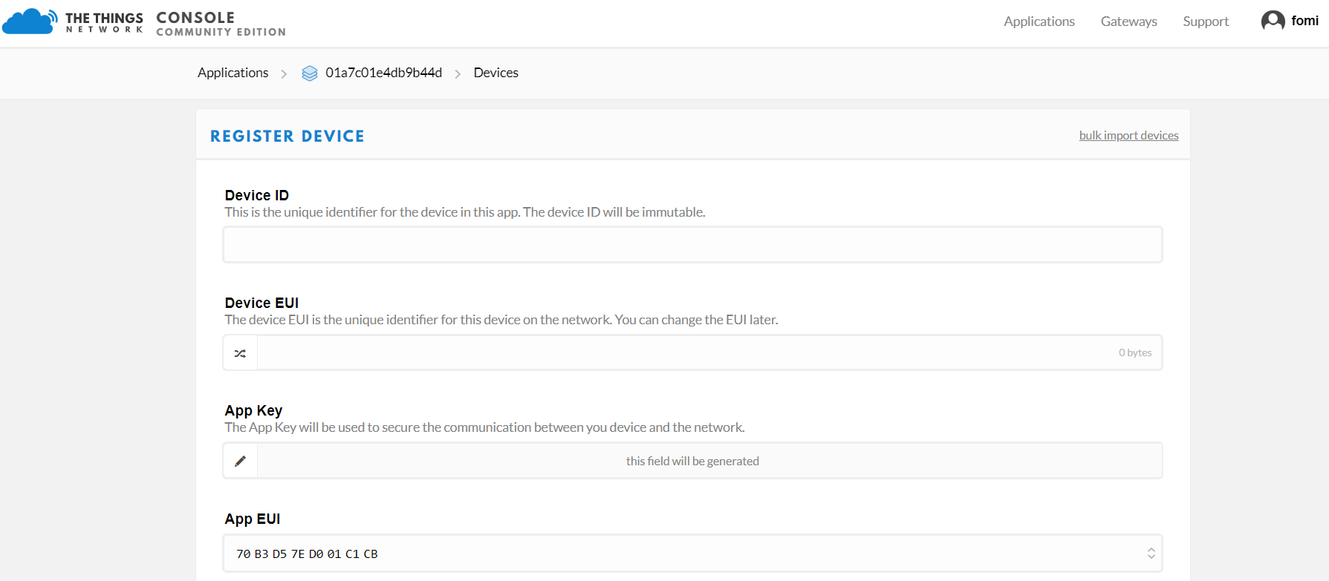

Please note that when you fill this value in “Device ID”, it must be in low case.

Also, you can click the following icon and “Device EUI” will be generated automatically in the next step:

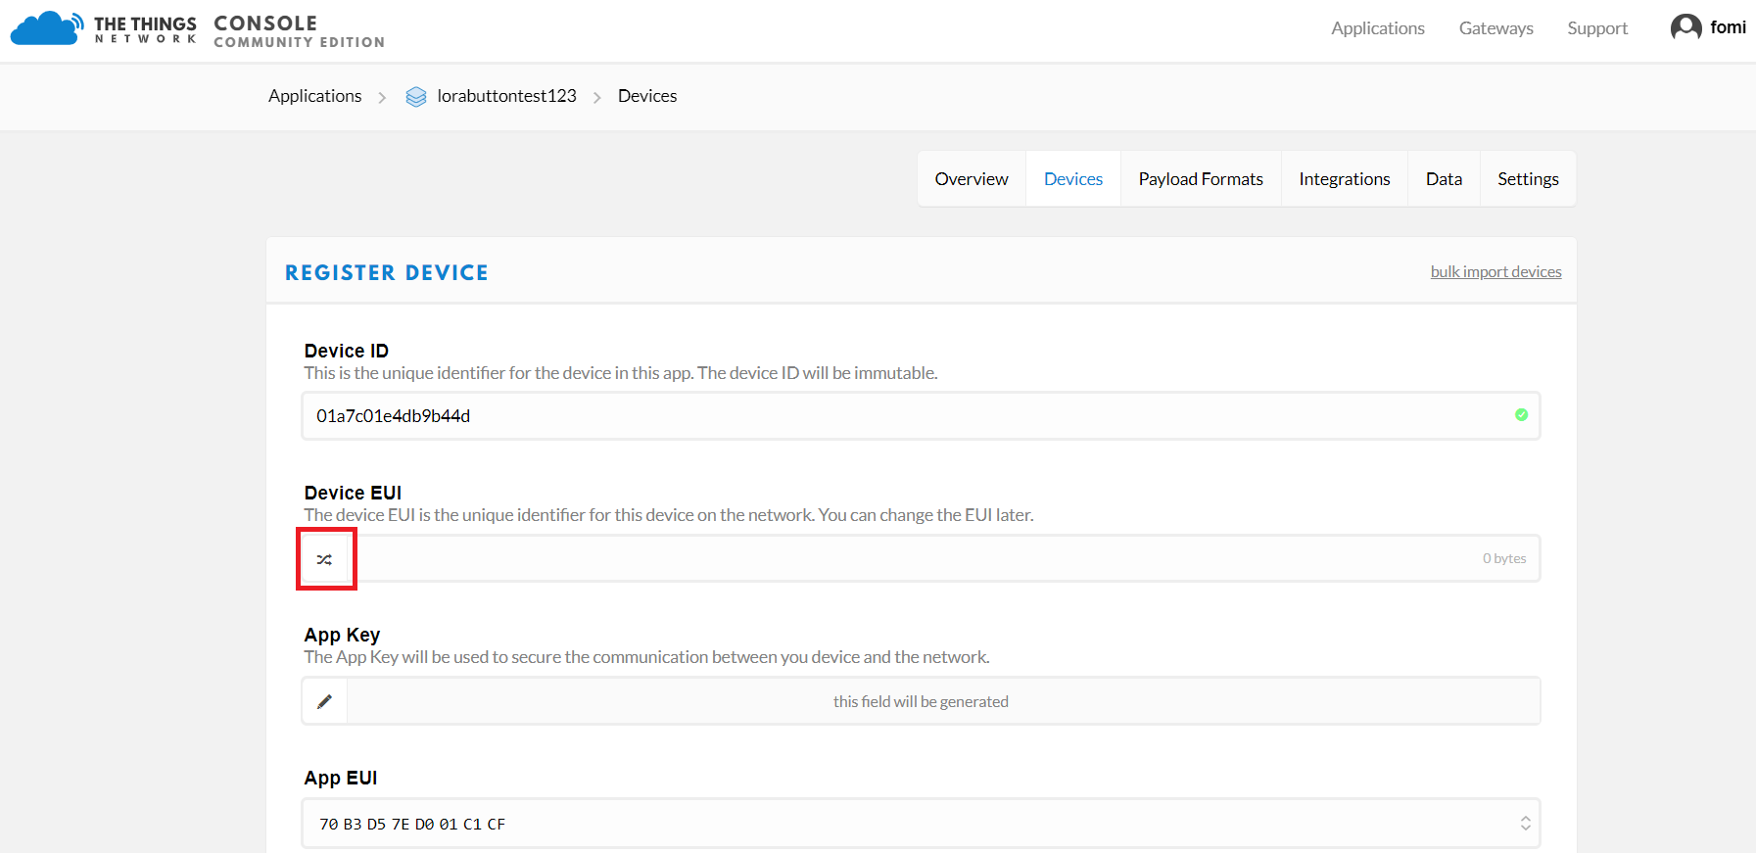

The following picture shows the final page:

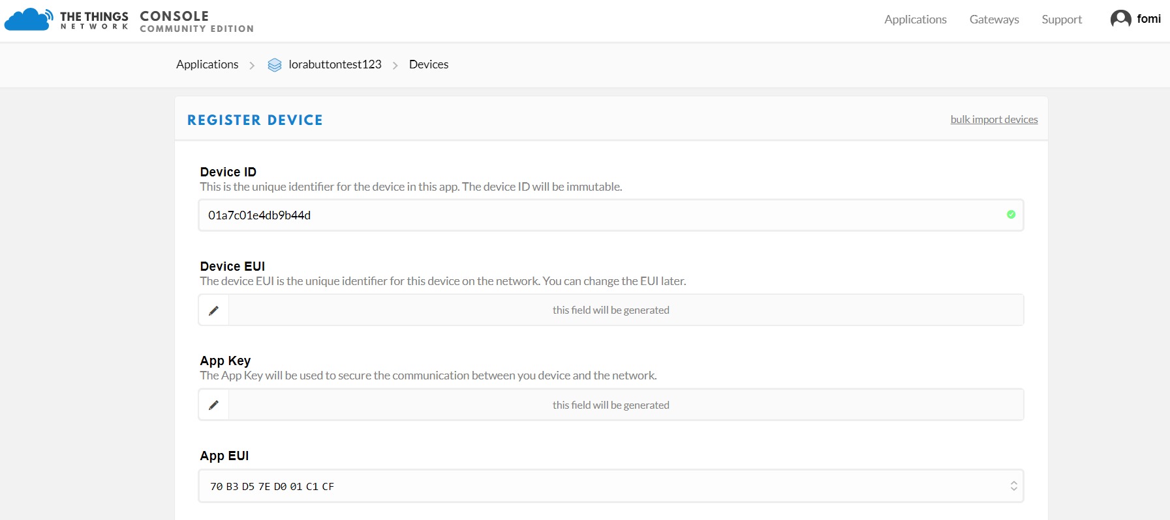

Then press the “Register” button at the bottom of this page to finish.

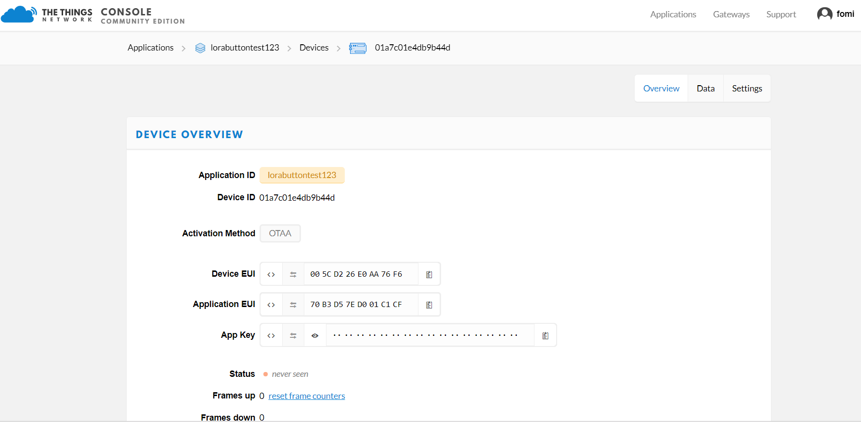

As you see, the default activation method is OTAA.

OK! Now, let’s join in OTAA mode and EU868 frequency for example!

Set the join mode to OTAA:

Set the Device EUI:

Set the Application EUI:

Set the Application Key:

Join in OTAA mode:

Join successfully!

Let’s press key 1 on RAK7201:

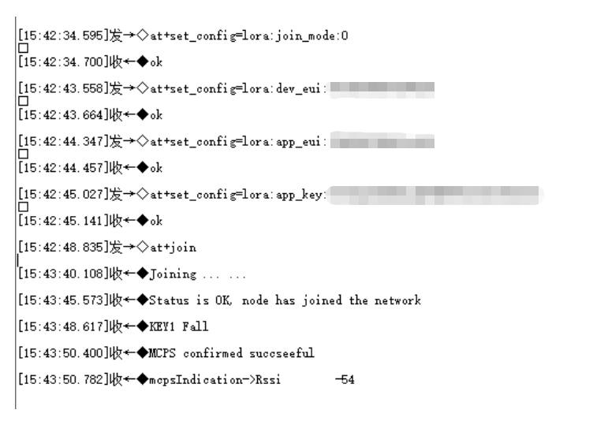

Now, you can see the status on TTN is active.

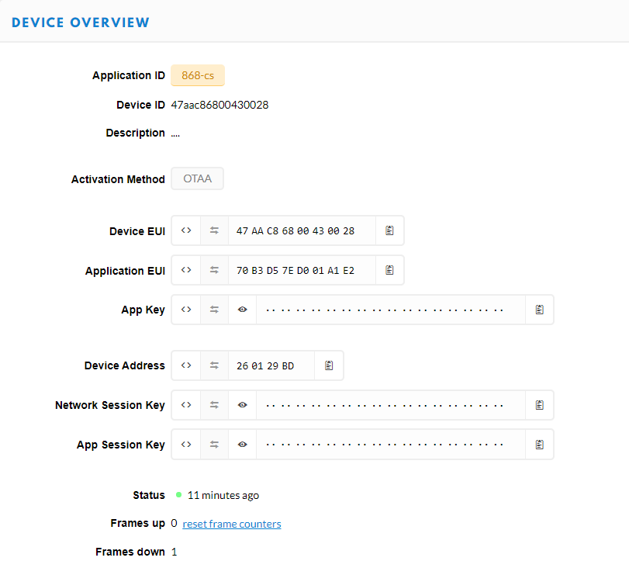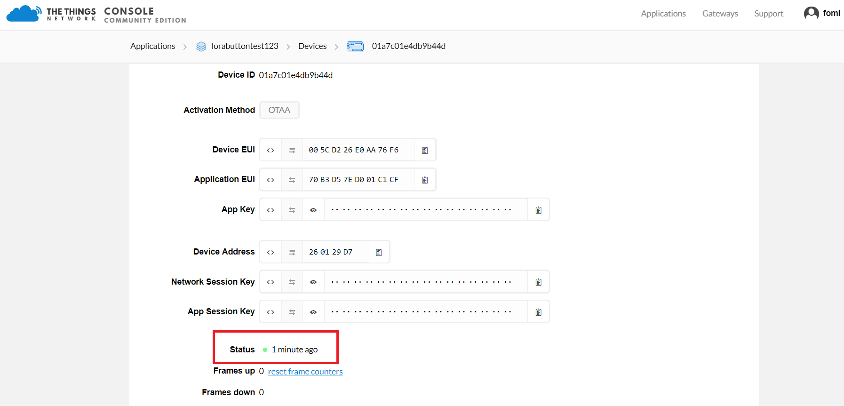

It will send some data to TTN automatically:

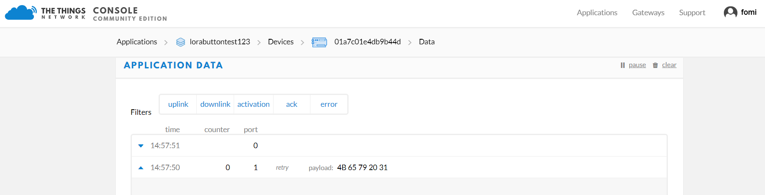

That’s all about OTAA.

Now, let’s try to join with TTN in ABP mode:

Firstly, click the “Settings” item as follow:

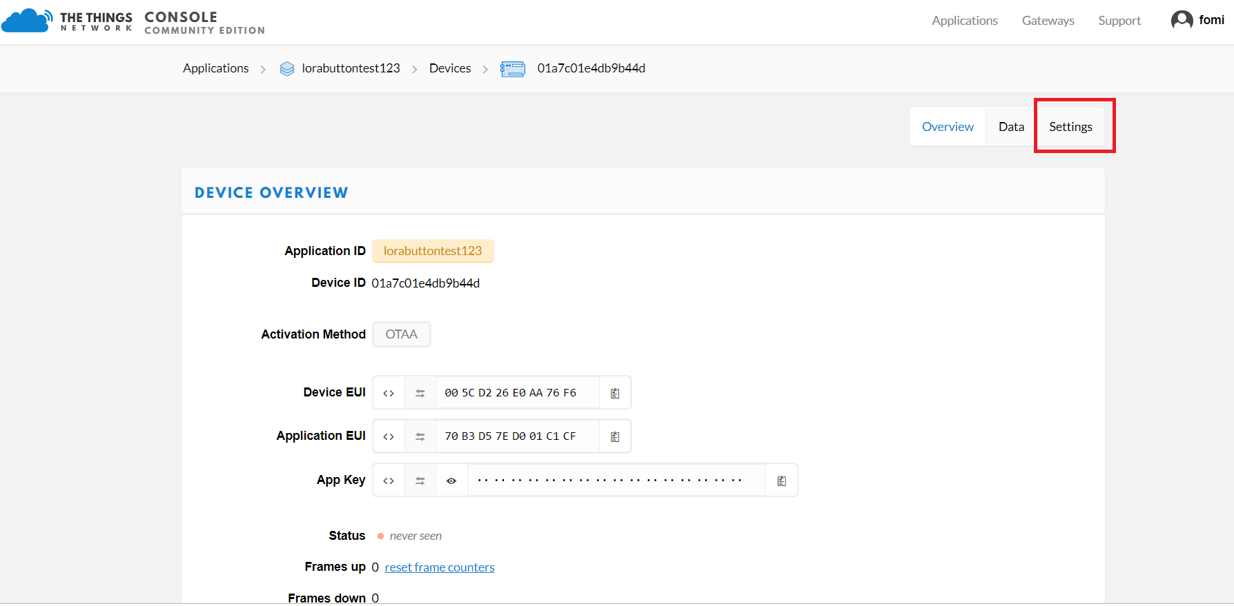

Click “ABP”:

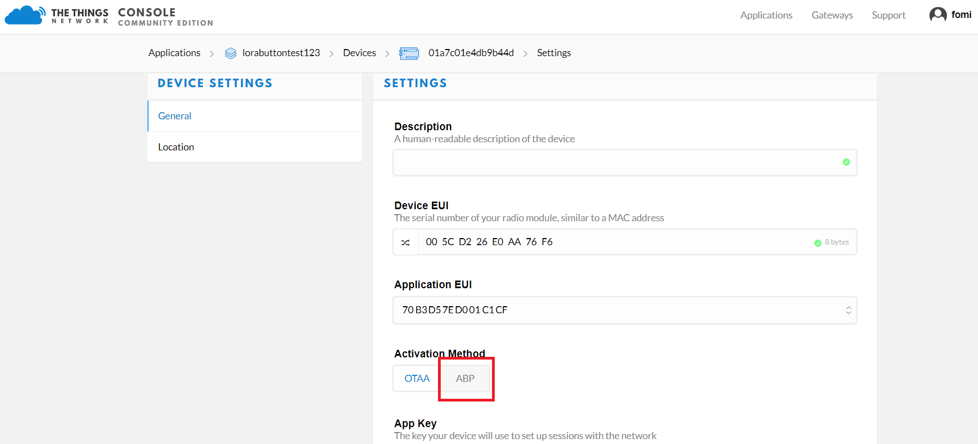

Then press the “Save” button at the bottom of this page, then you can see the following page:

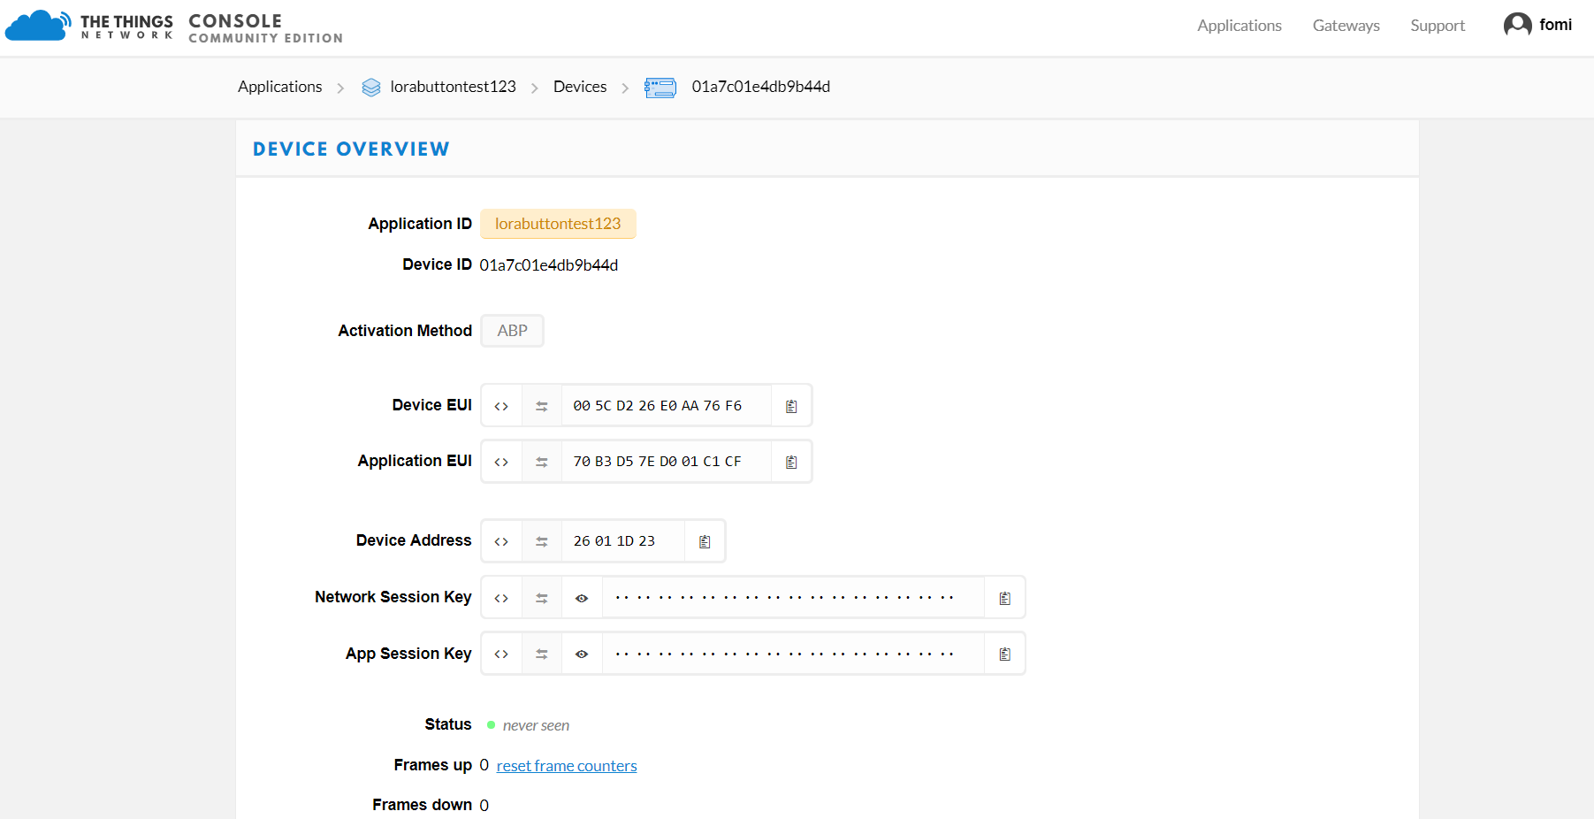

Now, the activation method is ABP.

Then, let’s configure RAK7201 using the following contents:

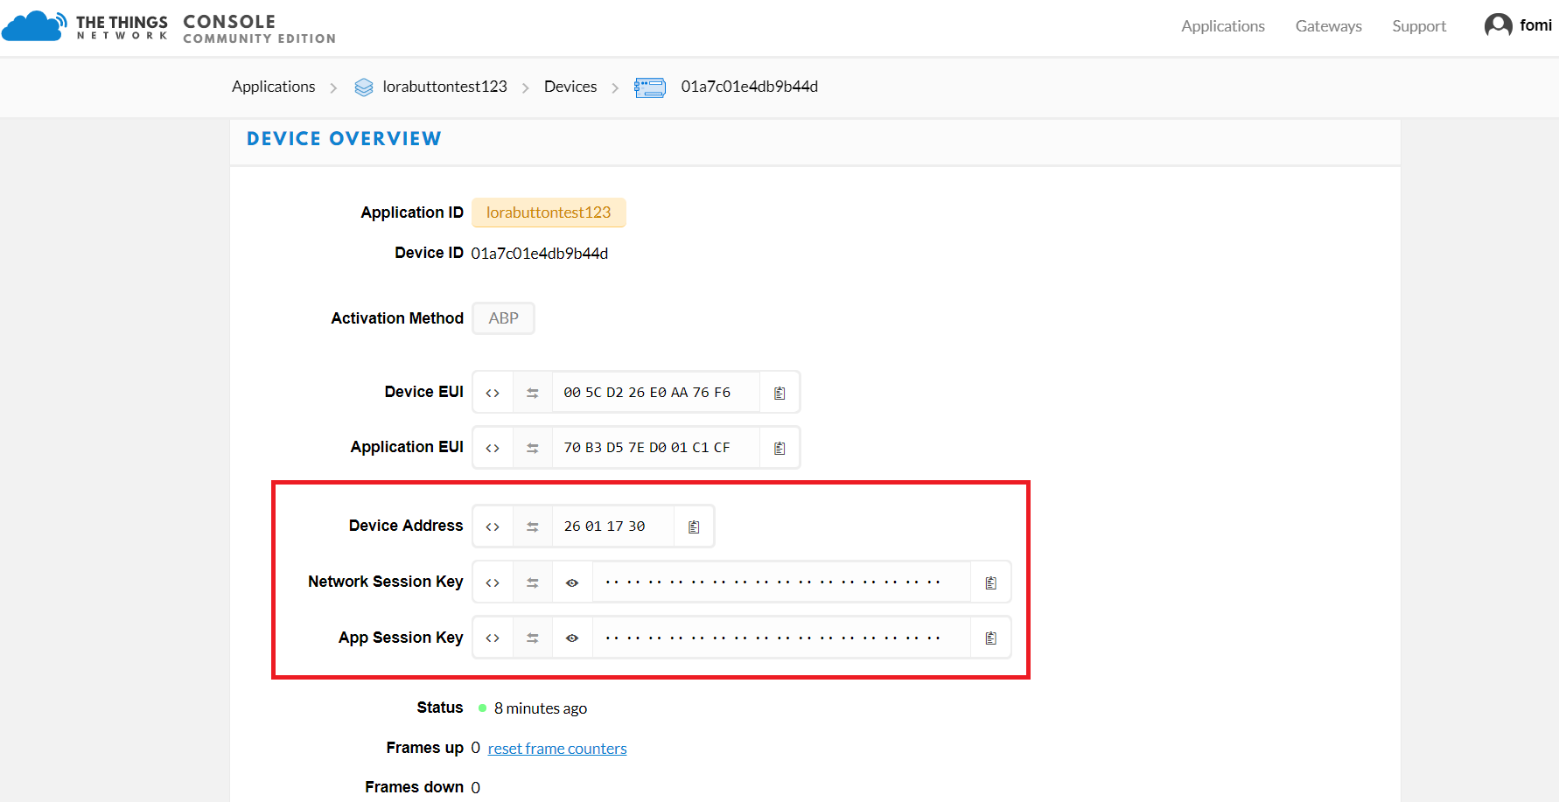

At first, set the join mode to ABP:

Set the device address:

Set the APP session key:

Set the network session key:

Join in ABP mode:

That’s OK. Now, let’s press key 3 on RAK7201:

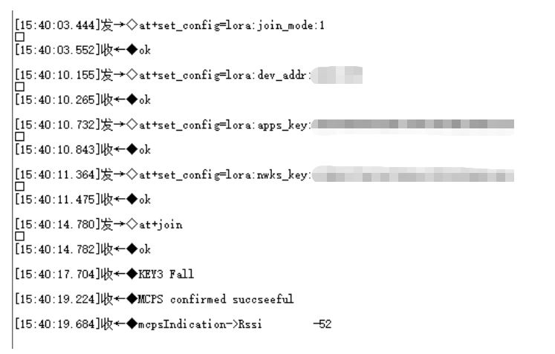

You can see the data on TTN:

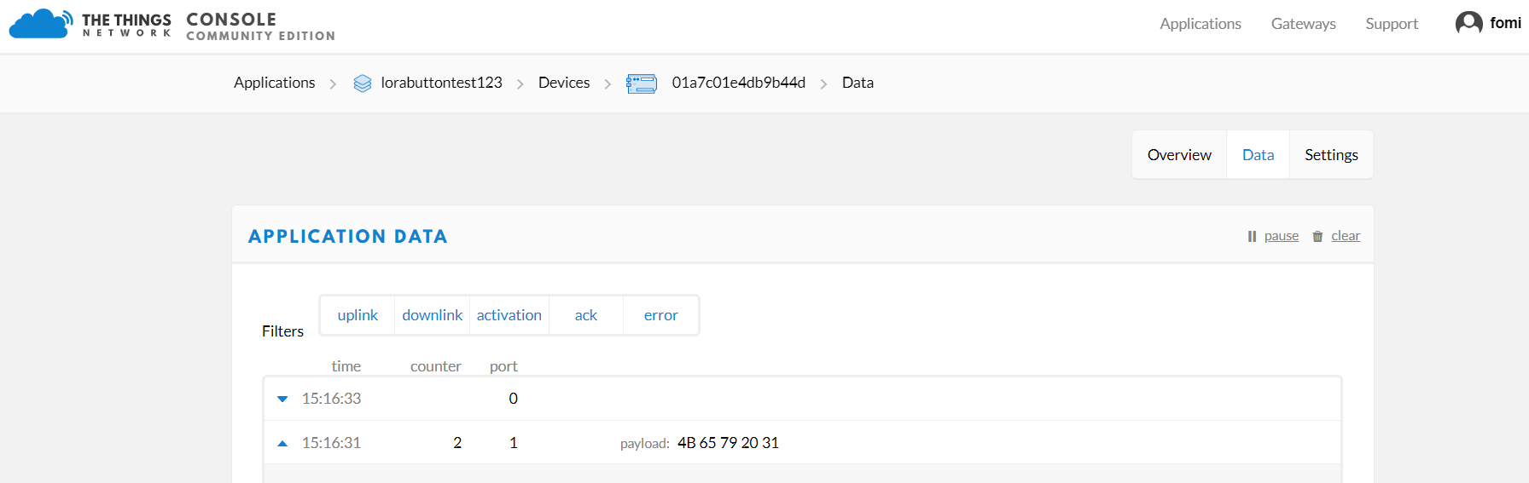

That’s all about ABP mode.

# **How to customize the function of 4 keys?**

From the v2.2.2 firmware on, we supply a function that you can customize the content freely for every key on RAK7201 when you press the key.

By default:

When you press key 1, it will send “KEY1 Fall”.

When you press key 2, it will send “KEY2 Fall”.

When you press key 3, it will send “KEY3 Fall”.

When you press key 4, it will send “KEY4 Fall”.

